**CMPE-277: Smartphone application Development**

**Assignment 1 - Activity Lifecycle**

**Submitted to:** Prof. Chandrasekar Vuppalapati

**Submitted by:** Anvit Saxena (SJSU ID: 010953436)



In this assignment, we demonstrate the concept of Android Activity Lifecycle. I have created an Android application that explains the working of Activity lifecycle using Thread counter. Whenever any activity is started, thread count increases. Following are the steps along with screenshots that explains in detail:

**Step 1:** The application “Activity Lifecycle” is opened and Activity A page comes up with thread count as 1 because onCreate() method of Activity A is called.

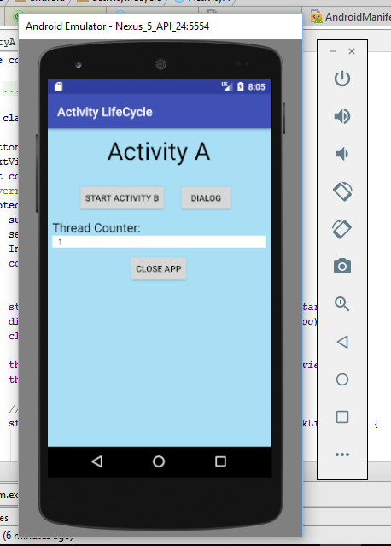

**Step 2:** As we click on Start Activity B the Activity B page opens up and the thread count is increased to 2 but we cannot display it yet. There is a button called “Finish B”. When we click it, it takes us back to Activity A page.

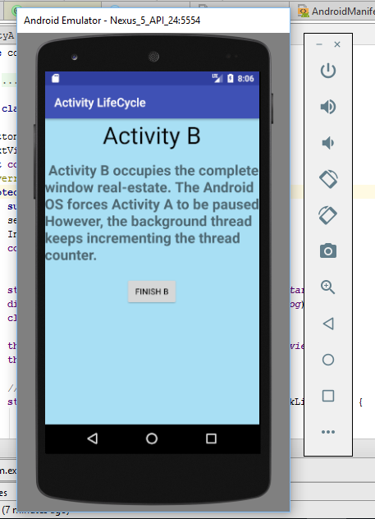

Step 3: Resumed Activity A and the thread count increases to 3 now.

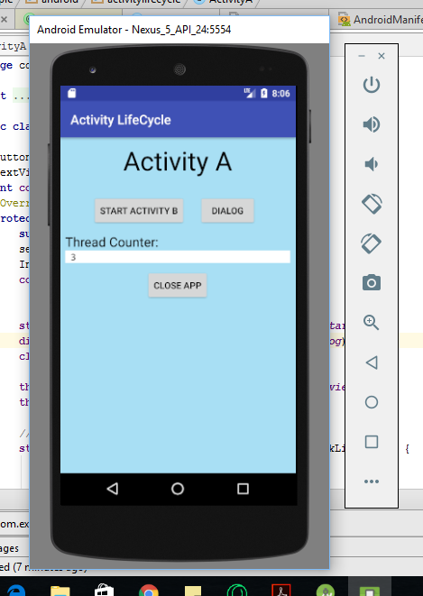

**Step 4:** Click Dialog Box button. A Simple Dialog box appears and Activity A is paused increasing the thread count to 4.

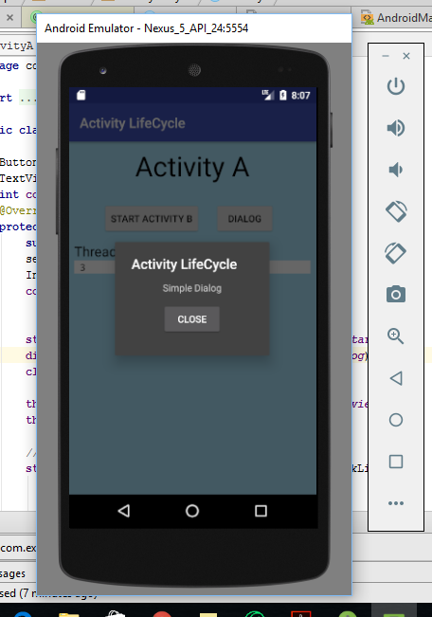

**Step 5:** Click on Close dialog box button and the Activity A is resumed back again with thread count increased to 5.

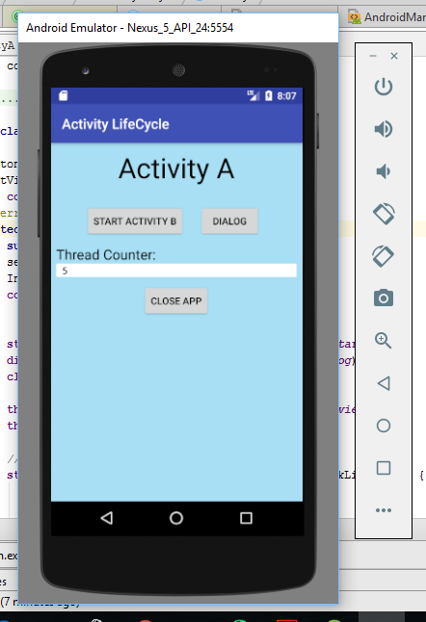

**Step 6:** Click on Close App button which closes the App and Home screen is displayed as shown below.

